**Linux File System Hierarchy**

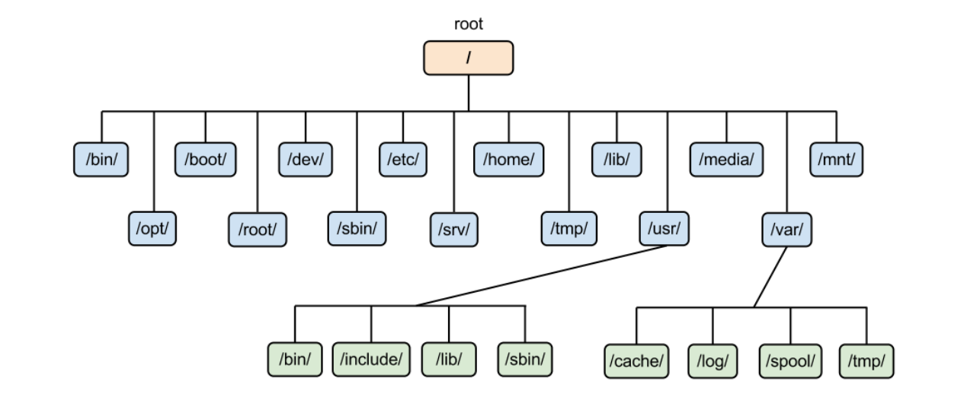

Linux file structure is organized in a hierarchical directory tree, which starts from a single root directory denoted by '/'. Here’s an overview of the main directories and their purposes:

1. / - The root directory, the starting point of the filesystem.

2. /bin - Contains essential binary executables (commands) needed for system booting and repairing.

3. /boot - Holds files required for the boot process, including the Linux kernel and initial RAM disk image.

4. /dev - Contains device files that represent hardware devices. These files allow software to interact with hardware.

5. /etc - Contains system-wide configuration files and settings for the system and applications.

6. /home - The default directory for user home directories. Each user has a subdirectory here (e.g., '/home/user').

7. /lib - Contains shared libraries needed by the binaries in '/bin' and '/sbin'.

8. /media - A mount point for removable media like USB drives and CD-ROMs.

9. /mnt - A temporary mount point for filesystems. Users can manually mount devices here.

10. /opt - Used for installing optional software packages.

11. /proc - A virtual filesystem that provides information about system processes and kernel parameters.

12. /root - The home directory for the root user (administrator).

13. /sbin - Contains system binaries, primarily for system administration tasks, that are usually run by the root user.

14. /srv - Contains data for services provided by the system (e.g., web server files).

15. /tmp - A directory for temporary files created by applications. This is usually cleared on reboot.

16. /usr - Contains user utilities and applications, including subdirectories like '/usr/bin' (for user commands), '/usr/lib' (libraries), and '/usr/share' (shared files).

17. /var - Contains variable data files, such as logs, databases, and spool files.

Each directory has a specific purpose, helping to maintain organization and manageability within the system. Understanding this structure is essential for effective navigation and administration of a Linux system.

**Basic Commands**

**File and Directory Management:**

1) ls: List files and directories.

Example: ls -la

Description: Displays all files and directories in long list format. "l" Long listing and "a" hidden file.

2) cd <directory>: Change the current directory.

Example1: cd /home/user

Description: Changes the current directory.

Example2: cd ..

Description: Back to previous directory.

3) pwd: Print the current working directory.

Example: pwd

Description: It will show the current working directory. Output might be: /home/user

4) mkdir <directory>: Create a new directory.

Example: mkdir test_folder

5) rmdir <directory>: Remove an empty directory.

Example: rmdir test_folder

6) rm <file>: Remove a file.

Example: rm file.txt

Description: Removes a file.

Example: rm -r test2_folder

Description: To remove a directory and its contents in Linux, you can use the rm command with the -r option, which stands for recursive.

7) cp <source> <destination>: Copy files or directories.

Example: cp test_file.txt copy_test_file.txt

Description: Copy files or directories to other directories or self-directories.

Example: cp -i test_file.txt copy_test_file.txt

Description: It will ask overwrite 'test_file.txt'?

Example: cp -r test_folder test2_folder

Description: It will copy the test_folder to test2_folder

8) mv <source> <destination>: Move or rename files or directories.

Example: mv old_file.txt new_file.txt

Description: It will rename the file name

Example: mv -i file1.txt dir1

Description: It will ask overwrite 'dir1/file1.txt'?

Example: mv dir1 dir2

Description: You can copy one directory to another directory

9) touch <file>: Create an empty file or update the timestamp of a file.

Example: touch test3.txt

Description: It will create empty file.

10) scp:

Example: scp /local/file username@remote_host:/path/

Description: SCP (Secure copy protocal): It is a command-line tool used for securely transferring files between a local and a remote host, or between two remote hosts, using SSH for encryption and authentication.

**File Viewing and Editing:**

1) cat <file>: Display the contents of a file.

Example: cat text1.txt

Description: Display the contents of a file.

Example1: cat > text2.txt

Description: you can create a new file and add contents there. After completion just type "ctrl+d" to save and exit

Example2: cat test1.txt test2.txt

Description: Display Contents of Multiple Files in one command

2) more <file>: View a file one screen at a time.

Example: more file1.txt

Description: View a file one screen at a time.

Note: you can go down side only and once contents end it will come out.

3) less <file>: View a file with the ability to scroll.

Example: less file1.txt

Description: It will show long contents of file. If you want to go up than press "Up Arrow Key" or Press "Space Key". If you want to go down than press "Down Arrow Key" or "b". If you want to file some text than press "/" and type text like "/city". It will search city in contents. Press "q" for come out from "less" command.

4) head <file>: Display the first few lines of a file.

Example: head -n 10 file.txt

Description: It will show 10 line form top. You can pass number according to your need.

5) tail <file>: Display the last few lines of a file.

Example: tail -n 10 file.txt

Description: It will show 10-line form bottom. You can pass number according to your need.

6) nano <file>: Open a file in the Nano text editor.

Example: nano file.txt

7) vi <file>: Open a file in the Vi text editor.

Example: vi file.txt

8) vim <file>: Open a file in the Vim text editor.

Example: vim file.txt

Description: Press i for --insert--, Press "Esc Key and :q" for quite, Press "Esc Key and :w" for write and Press "Esc Key and :wq" for write & quite

**System Information:**

1) uname -a: Show system information.

Example: uname -a

2) df -h: Display disk space usage.

Example: df -h

3) du -h <directory>: Show disk usage of a directory.

4) top: Display real-time system processes.

Example:

1) top -u username: Display processes for a specific user.

2) top -p pid: Monitor a specific process by its PID.

Description: The top (table of processes) command shows a real-time view of running processes in Linux and display kernel-managed tasks.

It will provide a system information summary that shows resource utilization, including CPU and memory usage.

You can come out form "top" command using "q" and enter.

Note: top then "k": Kill the press by PID

1. top then "d,s": To change interval of refresh
2. top then "u": To filter by usr
3. top then "r": You can change nice value (If nice value is greater than 0 means low and less than 0 means high [-20 to 19])
4. top then "m": Display Memory usage

5) ps aux: List all running processes.

6) free -h: Show memory usage.

7) uptime: uptime command displays the system's uptime.

Example: uptime

Description: uptime command displays the system's uptime, or how long it has been running, and when it was last booted.

8) nohup: The nohup command in Linux is used to run another command or script in the background, allowing it to continue running even after the user has logged out.

9) jobs: It will show active jobs

10) bg: Resume jobs to the background

11) fg: Resume jobs to the foreground

**Networking:**

1) ifconfig or ip a: Display network interfaces.

2) ping <hostname>: Check connectivity to a host.

3) curl <url>: Fetch data from a URL.

4) ssh <user>@<host>: Securely connect to a remote machine.

**User Management:**

1) whoami: Display the current user.

2) adduser <username>: Add a new user.

3) deluser <username>: Remove a user.

4) passwd <username>: Change a user's password.

5) su <options> <username>: switch to another user account.

**Package Management (Debian-based):**

1) apt update: Update package lists.

2) apt upgrade: Upgrade installed packages.

3) apt install <package>: Install a package.

4) apt remove <package>: Remove a package.

**Permissions:**

1) chmod <permissions> <file>: Change file permissions.

2) chown <user>:<group> <file>: Change file owner and group.